**Problem 1:** Transshipment Model

**Part A**: Determine the number of refrigerators to be shipped plants to warehouses and then warehouses to retailers to minimize the cost.

i. Formulate the problem as a linear program with an objective function and all constraints.

//all possible tuples of (plant, warehouse) and (warehouse, retailer) with associated costs

Minimize: 10(P1, W1) + 15(P1, W2) + 11(P2, W1) + 8(P2, W2) + 13(P3, W1) + 8(P3, W2) + 9(P3, W3) + 14(P4, W2) + 8(P4, W3) + 5(W1, R1) + 6(W1, R2) + 7(W1, R3) + 10(W1, R4) + 12(W2, R3) + 8(W2, R4) + 10(W2, R5) + 14(W2, R6) + 14(W3, R4) + 12(W3, R5) + 12(W3, R6) + 6(W3, R7)

Constraints:

//shipping capacity of each plant

(P1, W1) + (P1, W2) <= 150 //plant 1 supply

(P2, W1) + (P2, W2) <= 450 //plant 2 supply

(P3, W1) + (P3, W2) + (P3, W3) <= 250 //plant 3 supply

(P4, W2) + (P4, W3) <= 150 //plant 4 supply

//warehouses are not endpoints, and must ship all units to retailers

(P1, W1) + (P2, W1) + (P3, W1) – (W1, R1) – (W1, R2) – (W1, R3) – (W1, R4) = 0 //warehouse 1

(P1, W2) + (P2, W2) + (P3, W2) + (P4, W2) – (W2, R3) – (W2, R4) – (W2, R5) – (W2, R6) = 0 //warehouse 2

(P3, W3) + (P4, W3) – (W3, R4) – (W3, R5) – (W3, R6) – (W3, R7) = 0 //warehouse 3

//demand of retailers

(W1, R1) >= 100 //retailer 1 demand

(W1, R2) >= 150 //retailer 2 demand

(W1, R3) + (W2, R3) >= 100 //retailer 3 demand

(W1, R4) + (W2, R4) + (W3, R4) >= 200 //retailer 4 demand

(W2, R5) + (W3, R5) >= 200 //retailer 5 demand

(W2, R6) + (W3, R6) >= 150 //retailer 6 demand

(W3, R7) >= 100 //retailer 7 demand

//nonnegativity

All tuples >= 0

ii. Determine the optimal solution for the linear program using any software you want. Include a copy of the code/file in the report.

Lindo code:

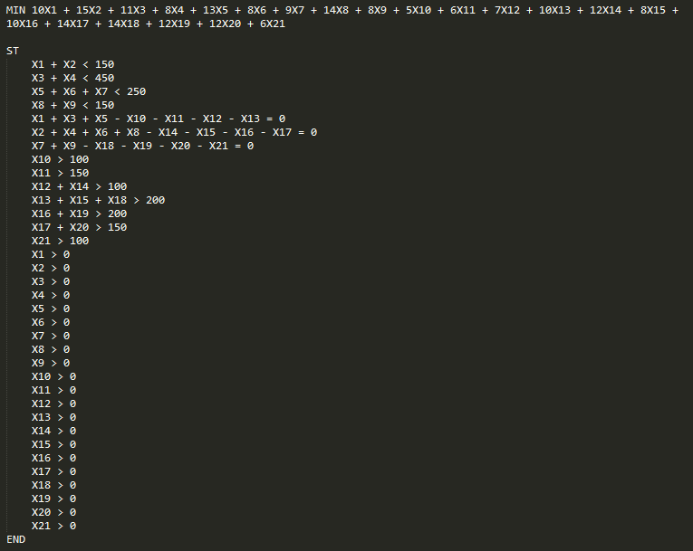

Report:

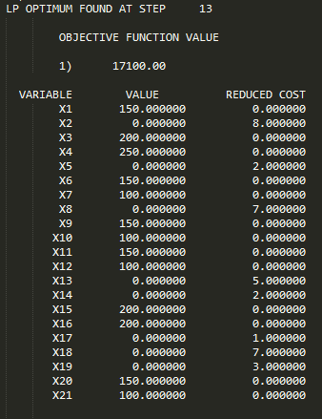

iii. What are the optimal shipping routes and minimum cost.

Minimum cost: $17, 100

Optimal shipping routes:

Plant 1 ships 150 units to Warehouse 1.

Plant 2 ships 200 units to Warehouse 1 and 250 units to Warehouse 2.

Plant 3 ships 150 units to Warehouse 2 and 100 units to Warehouse 3.

Plant 4 ships 150 units to Warehouse 3.

Warehouse 1 ships 100 units to Retailer 1, 150 units to Retailer 2, and 100 units to Retailer 3.

Warehouse 2 ships 200 units to Retailer 4 and 200 units to Retailer 5.

Warehouse 3 ships 150 units to Retailer 6 and 100 units to Retailer 7.

**Part B**: Due to old infrastructure Warehouse 2 is going to close eliminating all of the associated routes. What is the optimal solution for this modified model? Is it feasible to ship all the refrigerators to either warehouse 1 or 3 and then to the retailers without using warehouse 2? Why or why not?

Removing warehouse 2 from the equation results in the modified program below:

//all possible tuples of (plant, warehouse) and (warehouse, retailer) with associated costs

Minimize: 10(P1, W1) + 11(P2, W1) + 13(P3, W1) + 9(P3, W3) + 8(P4, W3) + 5(W1, R1) + 6(W1, R2) + 7(W1, R3) + 10(W1, R4) + 14(W3, R4) + 12(W3, R5) + 12(W3, R6) + 6(W3, R7)

Constraints:

//shipping capacity of each plant

(P1, W1) <= 150 //plant 1 supply

(P2, W1) <= 450 //plant 2 supply

(P3, W1) + (P3, W3) <= 250 //plant 3 supply

(P4, W3) <= 150 //plant 4 supply

//warehouses are not endpoints, and must ship all units to retailers

(P1, W1) + (P2, W1) + (P3, W1) – (W1, R1) – (W1, R2) – (W1, R3) – (W1, R4) = 0 //warehouse 1

(P3, W3) + (P4, W3) – (W3, R4) – (W3, R5) – (W3, R6) – (W3, R7) = 0 //warehouse 3

//demand of retailers

(W1, R1) >= 100 //retailer 1 demand

(W1, R2) >= 150 //retailer 2 demand

(W1, R3) >= 100 //retailer 3 demand

(W1, R4) + (W3, R4) >= 200 //retailer 4 demand

(W3, R5) >= 200 //retailer 5 demand

(W3, R6) >= 150 //retailer 6 demand

(W3, R7) >= 100 //retailer 7 demand

//nonnegativity

All tuples >= 0

It is not feasible to eliminate Warehouse 2 from the model. While all plants still have at least 1 warehouse available to ship to and all retailers are still serviced by at least 1 warehouse, Retailers 5, 6, and 7 are serviced exclusively by Warehouse 3. Even if Plan 3 and Plant 4 ship all supply to Warehouse 3, Warehouse 3 will have at most 400 units available. The combined demand from Retailers 5, 6, and 7, is 450, and so some demand (50 units) will be unmet (IE, a constraint is unsatisfiable). Therefore, there is no optimal solution.

Lindo code:

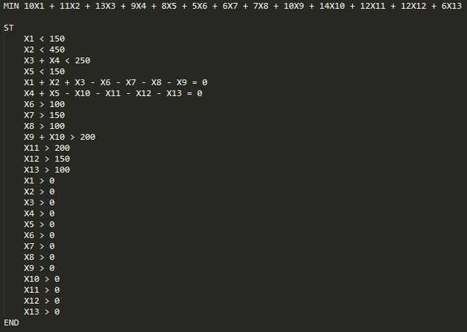

Lindo error:

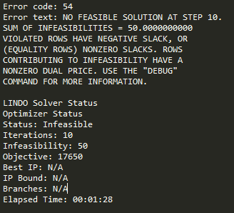

**Part C**: Instead of closing Warehouse 2 management has decide to keep a portion of it open but limit shipments to 100 refrigerators per week. Is this feasible? If so what is the optimal solution when warehouse 2 is limited to 100 refrigerators?

//all possible tuples of (plant, warehouse) and (warehouse, retailer) with associated costs

Minimize: 10(P1, W1) + 15(P1, W2) + 11(P2, W1) + 8(P2, W2) + 13(P3, W1) + 8(P3, W2) + 9(P3, W3) + 14(P4, W2) + 8(P4, W3) + 5(W1, R1) + 6(W1, R2) + 7(W1, R3) + 10(W1, R4) + 12(W2, R3) + 8(W2, R4) + 10(W2, R5) + 14(W2, R6) + 14(W3, R4) + 12(W3, R5) + 12(W3, R6) + 6(W3, R7)

Constraints:

//shipping capacity of each plant

(P1, W1) + (P1, W2) <= 150 //plant 1 supply

(P2, W1) + (P2, W2) <= 450 //plant 2 supply

(P3, W1) + (P3, W2) + (P3, W3) <= 250 //plant 3 supply

(P4, W2) + (P4, W3) <= 150 //plant 4 supply

//warehouses are not endpoints, and must ship all units to retailers

(P1, W1) + (P2, W1) + (P3, W1) – (W1, R1) – (W1, R2) – (W1, R3) – (W1, R4) = 0 //warehouse 1

(P1, W2) + (P2, W2) + (P3, W2) + (P4, W2) – (W2, R3) – (W2, R4) – (W2, R5) – (W2, R6) = 0 //warehouse 2

(P3, W3) + (P4, W3) – (W3, R4) – (W3, R5) – (W3, R6) – (W3, R7) = 0 //warehouse 3

//NEW constraint – Warehouse 2 cannot receive more than 100 units

(P1, W2) + (P2, W2) + (P3, W2) + (P4, W2) <= 100

//demand of retailers

(W1, R1) >= 100 //retailer 1 demand

(W1, R2) >= 150 //retailer 2 demand

(W1, R3) + (W2, R3) >= 100 //retailer 3 demand

(W1, R4) + (W2, R4) + (W3, R4) >= 200 //retailer 4 demand

(W2, R5) + (W3, R5) >= 200 //retailer 5 demand

(W2, R6) + (W3, R6) >= 150 //retailer 6 demand

(W3, R7) >= 100 //retailer 7 demand

//nonnegativity

All tuples >= 0

Adding 100 units of capacity to Warehouse 2 solves the issue we ran into in part B, by ensuring the demands of the retailers formerly only served by Warehouse 3 can now be met.

Lindo code:

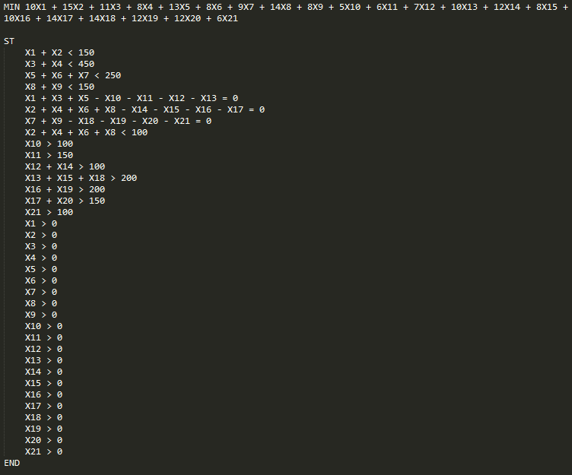

Report:

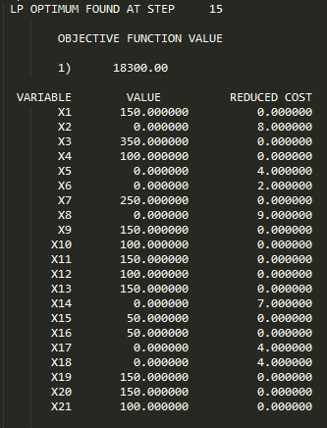

The optimal solution when Warehouse 2 is limited to 100 units of capacity is:

Minimum cost: $18,300

Optimal shipping routes:

Plant 1 ships 150 units to Warehouse 1.

Plant 2 ships 350 units to Warehouse 1 and 100 units to Warehouse 2.

Plant 3 ships 250 units to Warehouse 3.

Plant 4 ships 150 units to Warehouse 3.

Warehouse 1 ships 100 units to Retailer 1, 150 units to Retailer 2, 100 units to Retailer 3, and 150 units to Retailer 4.

Warehouse 2 ships 50 units to Retailer 4 and 50 units to Retailer 5.

Warehouse 3 ships 150 units to Retailer 5, 150 units to Retailer 6, and 100 units to Retailer 7.

**Part D**: Formulate a generalized linear programming model for the transshipment problem. Give the objective function and constraints as mathematical formulas.

Minimize cost(a, b) + cost(a, b+1) … for all valid values of b + cost (a+1, b) … for all valid values of a + cost(b, c) + cost(b, c+1) … for all valid values of c + cost(b+1, c) … for all valid values of b, where a = Plant #, b = Warehouse #, and c = Retailer #. A valid value is one where plant a is able to ship to warehouse b, or where warehouse b is able to ship to retailer c.

Constraints:

(a, b) + (a, b+1) … for all values of b <= capacity of a

Repeat with an additional constraint for each value of a

(a, b) + (a+1, b) … for all values of a, - (b, c) – (b, c+1) for all values of c = 0

Repeat with an additional constraint for each value of b

(b, c) + (b+1, c) … for all values of b >= demand of c

Repeat with an additional constraint for each value of c

All values of a, b, and c >= 0